ARYAMAN MISHRA

19BCE1027

FIRST BOOTLOADER(‘Blank Screen’)

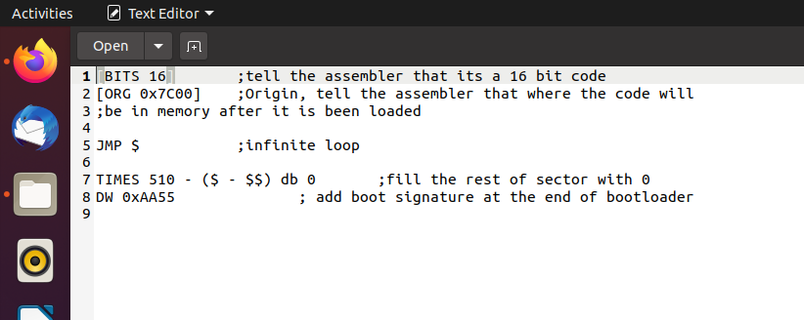

C:\Users\aryam\Desktop\0.2.PNG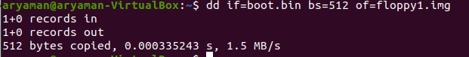



SECOND BOOTLOADER(‘A’)

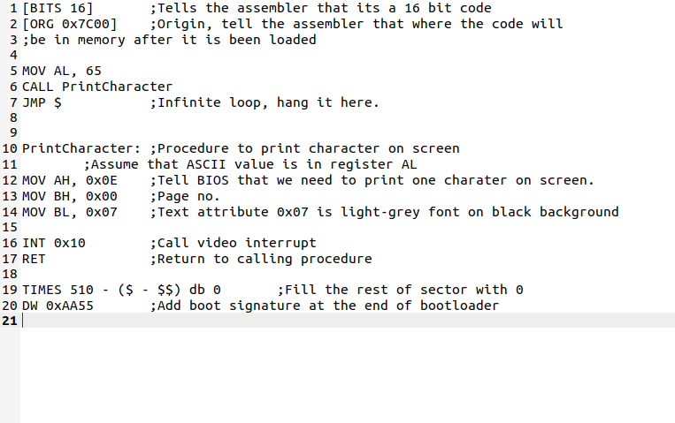

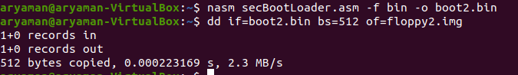

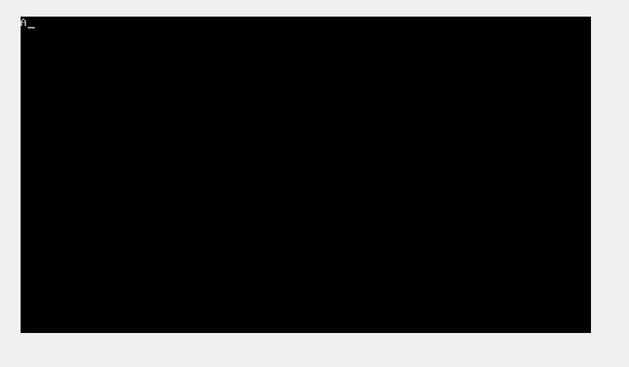

THIRD BOOT LOADER(HELLO WORLD)

